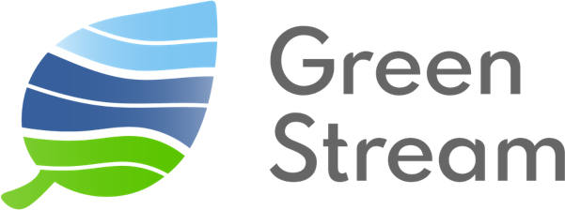

Technical Solution Proposal
Prepared by: Green Stream Technologies, Inc.
Prepared for: University of Virginia - Smart Septic Project
Date: January 2026

Purpose 3
Project Overview 4
Proposed Technical Solution 5
System Architecture 5
Products Supplied by Green Stream 5
Telemetry Platform: the Corbo Transceiver 5
Sensors 6
Surface Water Level 6
Groundwater Level 7
Rainfall (optional) 8
Soil Moisture in the Drainfield 9
Inside Septic Tank 9
Mounts 10
Cloud Services Supplied by Green Stream 10
Cloud Platform 10
Communication Services 10
Field Services Supplied by Green Stream 11
Site Study 11
Installation 11
Maintenance 12
Education and Training 12
Project Plan 12
Phase 1. Define 12
Phase 2: Develop 12
Phase 3: Deploy 12
Phase 4: Defend 12
Costs 13
Hypothetical Pilot Configuration 14
Contacts 16

Purpose
The Eastern Shore of Virginia faces a well-recognized challenge: in this rural, low-lying coastal environment, even moderate flooding can lead to septic system stress and failure. This creates a negative impact on public health, environment, and infrastructure. The University of Virginia (UVA), which maintains active facilities, student programs, and strong partnerships with local governments and schools in the region, approached Green Stream Technologies, Inc. (Green Stream) to explore a pilot project for a collaborative solution.
Green Stream is pleased to offer its proposed technical solution, products, services and project plan in support of UVA’s Smart Septic Project on the Eastern Shore.
Green Stream specializes in low-cost, scalable environmental sensing systems, making this a natural fit. Its role is contractor and supplier of sensing, telemetry and cloud data services, as well as collaboration with the UVA team in on-site field services.
The pilot will demonstrate the technical feasibility, reliability, and cost-effectiveness of this approach and produce a scalable model for broader deployment across the Eastern Shore and other vulnerable coastal regions.
UVA has communicated to Green Stream that it intends to kick off its pilot program at the beginning of 2026 by recruiting 5-10 households for participation. The full pilot will span over approximately 2.5 years.

Project Overview
Septic system performance in the Eastern Shore’s low-lying, coastal environment is highly sensitive to groundwater elevation, soil saturation, rainfall, and tidal influence. As described by UVA (Smart Septic Project description), early signs of septic stress are rarely observed until failure has already occurred.
Green Stream proposes a pilot-scale, integrated monitoring system that combines environmental measurements with septic system indicators to provide early warning of elevated failure risk. The system is designed to operate reliably in challenging field conditions using low-power sensors, autonomous power, and resilient communications.
For planning purposes, this proposal assumes a pilot deployment at approximately five (5) residential septic systems, with final site count determined by UVA. Final numbers can be adjusted as the pilot progresses and equipment needs are finalized.

Proposed Technical Solution

System Architecture
Each monitoring site consists of:
- Environmental sensor
- Environmental transceiver
- Autonomous energy system
- Cloud communications module
- Mount hardware
Sensors connect to the transceiver, which provides each sensor power, data acquisition, local buffering, and encrypted transmission to Green Stream’s cloud platform. Data is made available to UVA through dashboards, exports, and APIs.

Products Supplied by Green Stream

Telemetry Platform: the Corbo Transceiver
- Sensor-agnostic integration platform
- LTE Cat-M1 communications with multi-carrier support
- Optional satellite communications for redundancy
- Encrypted data transmission and OTA updates
- Supports up to two co-located sensors per unit
Green Stream’s Corbo Environmental Transceiver is a rugged, two-way IoT communications and power platform that enables many types of environmental sensors to report reliable, high-integrity data to the cloud—continuously and with minimal on-site maintenance. The Corbo is designed to power and manage attached sensors, collect measurements on a configurable schedule, and transmit both sensor data and device-health telemetry (e.g., battery voltage and signal strength) to Green Stream’s cloud platform for real-time visualization, alerts, and API access.
As a platform, the Corbo is built for the real world: coastal humidity, salt air, storms, and hard-to-reach sites. Corbo systems are deployed with industry-grade sensors and engineered for “RAD” performance—Reliable (always on), Accurate (data you can trust), and Durable (weather-tough)—supporting long-lived field installations where uptime matters.
The Corbo is a sensor-agnostic integration (a platform, not a single-purpose device). It is used across Green Stream deployments to connect a range of third-party sensors into one consistent reporting and management system, with the transceiver, power, and cloud services working together as an integrated stack. A single Corbo transceiver is capable of supporting up to two environmental sensors if co-located at the same site.
For the Smart Septic project, the Corbo supports LTE communications where available (with LTE Cat-M1 multi-carrier switching), and Iridium IMT communications where LTE is unreliable or non-existent.
The Corbo features an autonomous power system, with an onboard rechargeable battery supported by an external high-efficiency solar panel.
The Corbo is designed for harsh environments with IP68 / NEMA 4-class enclosure protection. It features encrypted communications and over-the-air (OTA) updates for security and lifecycle performance. Its configurable report rate (as frequent as every five minutes) combined with its real-time communication to the cloud, are important when linking septic-stress indicators with rainfall, tide, groundwater signals.

Sensors
UVA has identified five monitoring functions for environmental conditions leading to septic tank overwhelm. Green Stream proposes Corbo-compatible sensor solutions to address each domain.
Monitoring Function | Sensor
Surface Water Level | Non-contact ultrasonic or radar
Groundwater Level | Shallow piezometer with pressure transducer
Rainfall (optional) | Radar disdrometer (if needed)
Soil Moisture in the Drainfield | In-soil moisture sensor
Septic Tank Level | Partner with septic professional

Surface Water Level
Sensor: Non-contact ultrasonic or radar sensor
Purpose: Monitor early signs of septic system stress influenced by bays, inlets, coves, tidal rivers and creeks, and ponds
Green Stream has deployed over 400 non-contact sensors in coastal, plains, and mountain environments, and works with a range of sensors to meet the requirements at different sites. Ultrasonic sensors offer a cost-effective solution for continuous measurement, while radar sensors, though slightly more expensive, provide higher reliability and performance under challenging conditions. Both options can feed real-time data into the early-warning system, enabling residents and local agencies to respond proactively to potential septic stress.
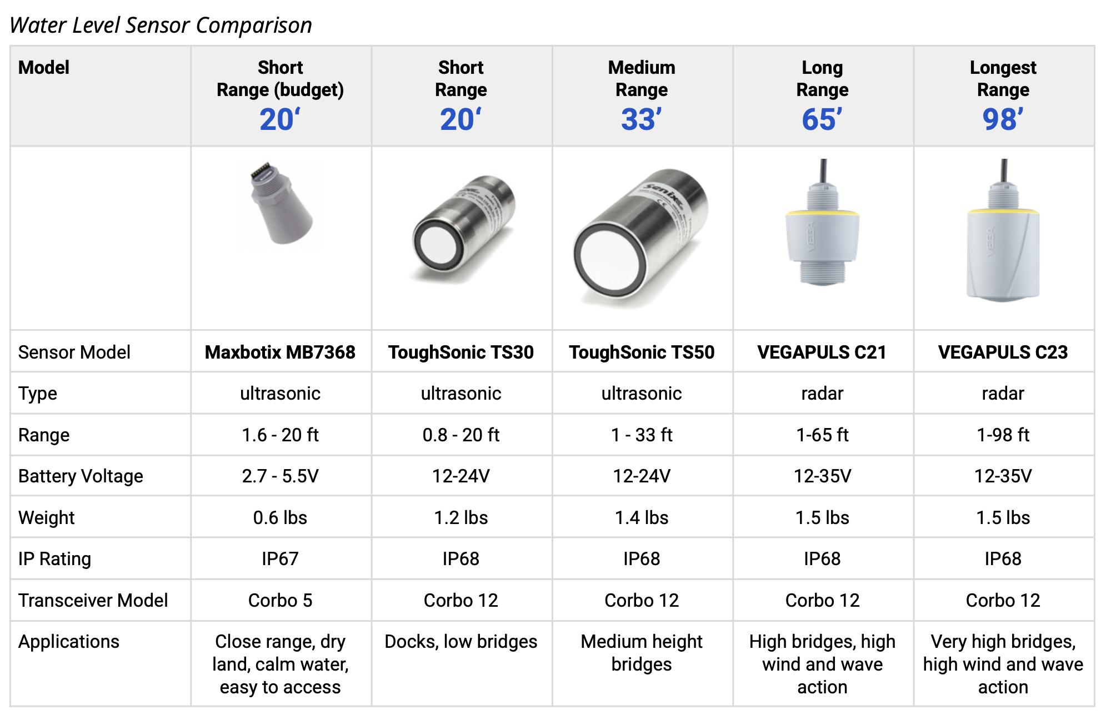

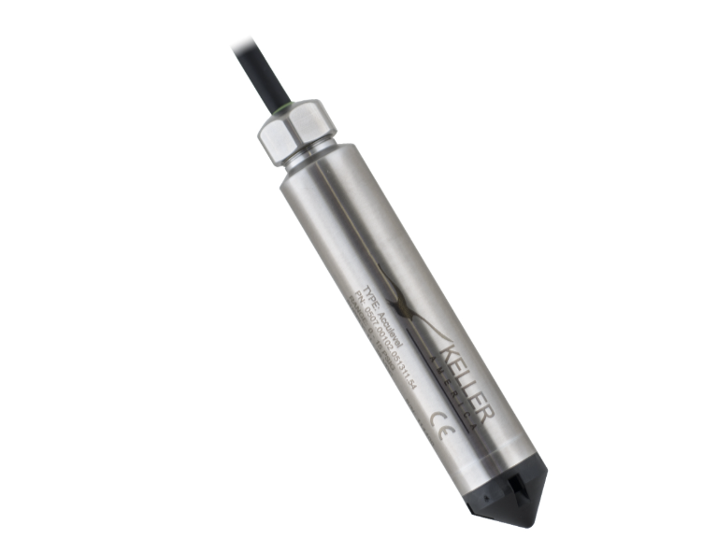
Groundwater Level
Sensor: Shallow piezometer with pressure transducer
Purpose: A piezometer is a small-diameter monitoring well installed into the ground to directly measure groundwater levels. Unlike soil moisture probes that infer wetness, a piezometer provides a direct measurement of water table elevation—the most definitive indicator of groundwater saturation affecting septic system performance.
Well: 3 feet deep, PVC pipe 2 inches in diameter, 3-3.5 feet long with lower 1-2 feet slotted or screened to allow water ingress. Locking cap at the surface. Gravel pack around screened portion. Bentonite seal above the screen to prevent surface water intrusion. Benefits of shallow, narrow well: minimal disturbance to property, lower installation cost, faster permitting, adequate for shallow groundwater measurement.
Pressure Transducer Instrumentation: Green Stream proposes the Keller AccuLevel with titanium housing to withstand potential corrosion from salt or brackish water, or septic runoff.
Range: 0-1m
Output: RS-485
Resolution: 0.002%
Options: Titanium enclosure, non-vented (absolute)
IP Rating: IP68
Transceiver Model: Corbo 12

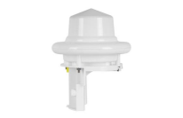
Rainfall (optional)
If the project requires location-specific rainfall data and doesn’t find a reliable source, Green Stream proposes the Lufft WS-100 24 GHz doppler radar precipitation sensor. The Lufft WS-100 is a compact, solid-state precipitation sensor that measures rainfall intensity and accumulation without moving parts. Unlike traditional tipping-bucket gauges, it requires virtually no maintenance, eliminating mechanical wear, clogging, and recalibration caused by debris, insects, or sediment. Its lightweight design and simple mounting enable fast, low-impact deployment, making it well suited for distributed installations where reliability, accuracy, and minimal site visits are critical.

Gauge | Radar Disdrometer
Model | Lufft WS100
Type | Radar: 24GHz doppler radar
Heating | included
Types of precipitation detected | rain, snow, sleet, freezing rain, hail, drizzle
Measurements returned | Precipitation intensity up to 200mm/hr  Droplet size 0.3 to 5mm  Particle velocity up to 15.5 m/s Solid precipitation 5.1 to 30mm
Power Needs | 10-28V
Power consumption | 1.5mA standby, 15mA in operation,  750mA when heater is on
Resolution | 0.01 / 0.1 / 0.2 / 0.5 / 1.0mm
Accuracy | 0.16mm or 10% of measured value up to 200mm/hr
Weight | 1.35 lbs
IP Rating | IP66

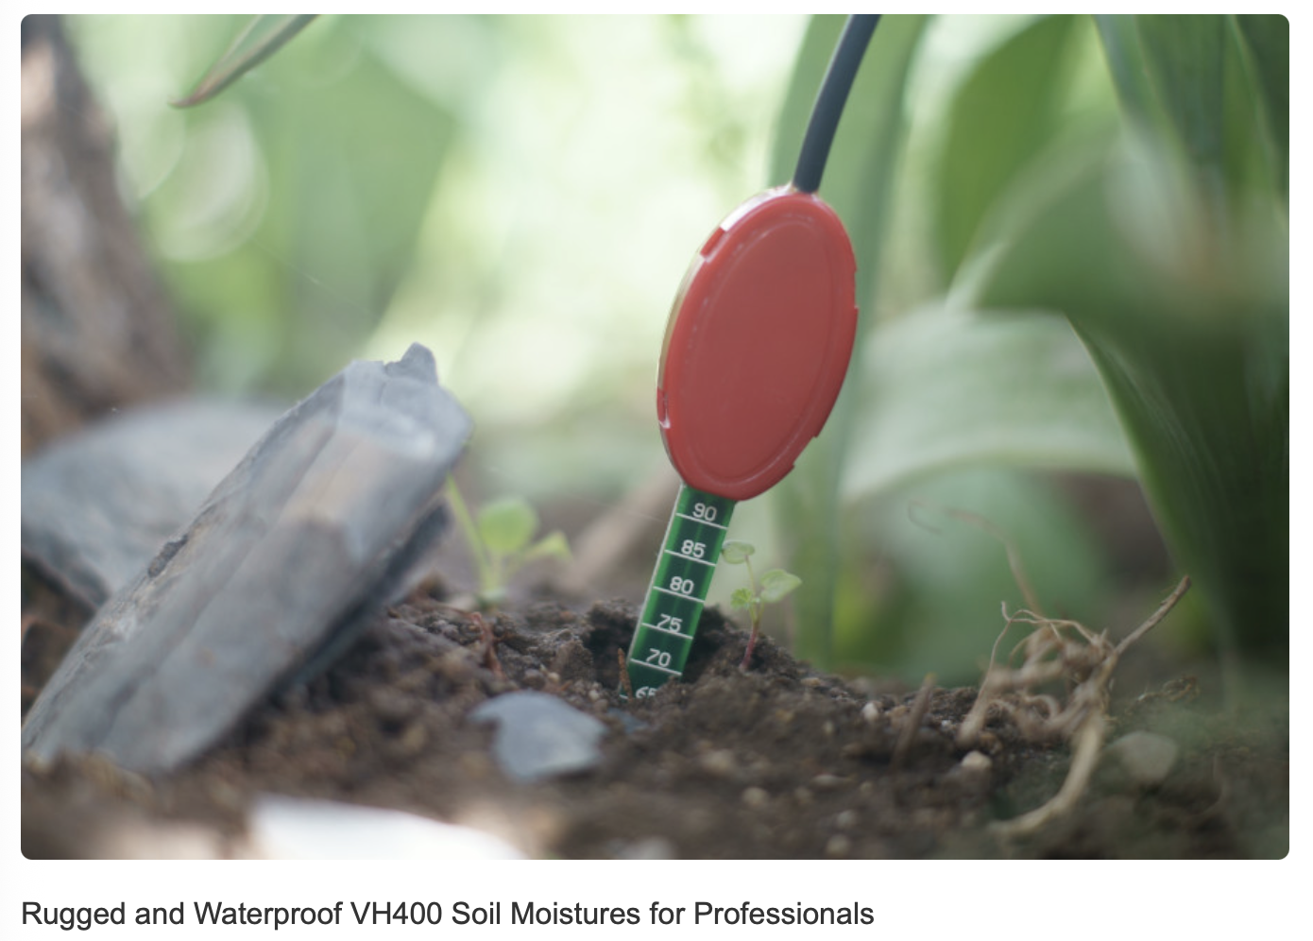
Soil Moisture in the Drainfield
Green Stream proposes a capacitive sensor to detect soil moisture in the drainfield. Capacitive sensors measure the soil's dielectric permittivity (ability to store charge), which increases with water content, providing accurate volumetric water content.
The Vegetronix VH400 is used most often in agricultural applications. It is notable for its flexibility to work with a variety of data loggers and transceivers, as well as its resistance to salt corrosion.

Inside Septic Tank
During the pilot phase, septic system risk will be inferred using environmental and subsurface indicators rather than invasive tank instrumentation. This approach minimizes site disturbance, reduces installation complexity, unknowns, and liability risk, and aligns with best practices for early-warning detection. During the pilot phase, Green Stream proposes correlating data from the environmental sensors with existing tank high water alarms triggered for example by internal float switches.
Direct tank monitoring utilizing non-contact ultrasonic or radar, or other solutions may be evaluated in future phases in coordination with licensed septic professionals.
Should UVA wish to include direct tank monitoring in this phase, Green Stream is willing to work for a solution in partnership with a septic professional. Once Green Stream has examined the chosen septic tank and their design(s), a solution can be developed, priced, and tested.

Mounts
Green Stream has standard mount designs which are approved and in use on Virginia Department of Transportation (VDOT) regulated bridges throughout the Commonwealth of Virginia. Similarly, Green Stream has mount solutions for most docks and piers. In addition, Green Stream has a partner metal fabricator in Norfolk VA who can build to design. All mounts are made of non-corrosive metals and can withstand coastal conditions.

Cloud Services Supplied by Green Stream
Cloud Services include Green Stream’s Cloud Platform and Communication services. Integrations and enhancements are also available upon request.

Cloud Platform
Green Stream will host the Customer’s data on greenstream.cloud, its secure AWS Cloud Platform. This centralized platform provides:
- Time-series data storage and visualization
- Site-level dashboards and mapping
- Network and device management
- Automated alert generation
- APIs
Green Stream’s cloud platform is SOC-2 certified, and is a COVRamp vendor approved by the Virginia IT Agency (VITA) for use in Virginia public agencies and schools.
Green Stream offers an optional integration for surface water level and precip data to the Virginia Flood Monitoring System (VFMS) operated by the Virginia Department of Emergency Management (VDEM) and to the National Water Prediction Model (water.noaa.gov) operated by the National Weather Service (NWS).

Communication Services
Green Stream provides partner cellular and/or satellite communications bundled with its cloud data platform to support reliable operation in a rural, coastal environment where connectivity can be variable. Managing communications as part of the end-to-end monitoring system provides full visibility into device connectivity, signal quality, and data delivery, enabling rapid troubleshooting and remote system management. This integrated approach supports secure over-the-air configuration and updates, reduces the need for field visits, and improves system reliability during storm events and periods of elevated risk—conditions that are central to the project’s objectives.
Bundled communications also enable the use of multi-carrier cellular technology, allowing monitoring stations to automatically connect to the strongest available network at each site and to fail over if a carrier experiences service degradation or changes coverage in the region. This flexibility is particularly important on the Eastern Shore, where reliance on a single carrier can limit deployment locations and long-term system resilience. Centralizing communications, cloud services, and technical support under a single provider simplifies operations, clarifies responsibility for system performance, and reduces lifecycle risk, while remaining compatible with alternative connectivity arrangements where institutional requirements apply.

Field Services Supplied by Green Stream
Green Stream is happy to partner with UVA faculty, students and interns for deployment and field testing of the sensor equipment. We recommend that a Green Stream technician be present and able to support UVA’s field team with technical expertise at the time of the Site Study, and during Installation.

Site Study
Pre-installation planning must include a Site Study to visit candidate sites, take measurements and photos and assess the conditions in which the sensor must perform. Green Stream uses a six-point site evaluation:
- Sensor performance - how will the sensor perform at this site, what type of sensor is needed
- Solar - does the site get enough sun exposure for solar panels
- Signal - measure LTE signal and carrier in the area, note RSSI, SNR, and carrier detected
- Structure - on what structure will the sensor be mounted and what type of mount is needed
- Safety - what safety concerns are present - traffic, fall risk, drowning risk, wildlife risk
- Susceptibility - is the site susceptible to vandalism, inundation of the equipment or other environmental damage

Installation
Green Stream ensures that all equipment is installed in a workman-like manner, observing all OSHA and VDOT safety rules, and that the equipment is operational before leaving the site. If necessary, Green Stream can subcontract traffic control from its partners.
Our engineering technician has done hundreds of solo installations and is also experienced training and supporting third party teams during installation. He will happily work with the UVA team.

Maintenance
It is our understanding that maintenance will be performed by the UVA student team. Green Stream is available for troubleshooting and repairs. In case maintenance becomes impractical for the student team, Green Stream offers tiered maintenance service contracts.

Education and Training
Green Stream offers training, from a simple online session orienting students to the device electronics and network maintenance tools to a more advanced in-classroom look behind the scenes. Green Stream would be happy to work with students under the grant project, with interns, and defined student projects.

Project Plan
Environmental sensor projects typically follow a 4-phase approach.

Phase 1. Define
- Finalize monitoring objectives with UVA
- Site Studies and Selection, with Site Report
- Equipment Selection and Configuration
- Cloud Services Configuration

Phase 2: Develop
- Procure, assemble, configure, test equipment
- Set up secure cloud services and APIs
- Integration test of full system
- Installation planning and coordination, including any necessary permitting

Phase 3: Deploy
- Install devices at selected sites
- Conduct surveys and set thresholds
- Activate cloud services
- Verify data quality and flow

Phase 4: Defend
- Ongoing Cloud Services and Communications, renewable annually
- Support for Continuous Monitoring & Maintenance

Costs
This proposal includes a hypothetical pilot configuration for planning purposes only. A detailed cost schedule with unit pricing is provided as a separate attachment “Smart Septic Lot Sheet 2026”
Cost categories include:
- Environmental Sensing Kits including sensor - transceiver - power system and enclosures
- Mounts
- Installation and field support
- Communications and cloud services
- Technical support and maintenance
Final costs will depend on the number of sites, site conditions, sensor selection, and level of support desired during the pilot.

Hypothetical Pilot Configuration
This Hypothetical Pilot Configuration is modeled on a minimum viable project. Quantities and items can be tweaked, and Green Stream can budget additional support or work requested by UVA.
Assumption: Five homes selected, 15 monitoring locations - 5 surrounding water bodies, 1 groundwater monitoring near each home, and 1 moisture sensor in each drainfield.

Item | Unit | Number  of Units | Cost  per Unit | Extended  Cost
Phase 1: Define
Site Study | per site | 15 | $245.00 | $3,675.00
Lead Systems Engineer | per hour | 16 | $190.00 | $3,040.00
Hotel per diem | per night | 1 | $110.00 | $110.00
Meals per diem | per day, per person | 2 | $68.00 | $136.00
Senior Technician | per hour | 16 | $110.00 | $1,760.00
Lead Systems Engineer | per hour | 16 | $190.00 | $3,040.00
Hotel per diem | per night | 1 | $110.00 | $110.00
Mileage round trip | miles | 400 | $0.725 | $290.00
CBBT | round trip crossing | 1 | $42.00 | $42.00
Documentation | hours | 32 | $95.00 | $3,040.00
Project Management/Quality Control | hours | 24 | $120.00 | $2,880.00
Sub-total Phase 1 |  |  |  | $18,123.00
Phase 2: Develop
Equipment
Water Level Sensor Kit 20 ft range  with Senix TS30 ultrasonic | kit | 5 | $2,100.00 | $10,500.00
Mounts - bridge or dock | per site | 5 | $525.00 | $2,625.00
Water Level Sensor Kit 0-3 ft range  with Keller Acculevel Pressure Transducer | kit | 5 | $4,250.00 | $21,250.00
Shallow Monitoring Well and telemetry mast | per site | 5 | $650.00 | $3,250.00
Moisture Sensor Kit with V400 capacitive sensor | kit | 5 | $1,200.00 | $6,000.00
Telemetry mast | per site | 5 | $120.00 | $600.00
Sub-total Equipment |  |  |  | $44,225.00
Services
Cloud Setup, Tier 2 |  | 1 | $2,750.00 | $2,750.00
NWS Integration Setup, Tier 2 |  | 1 | $800.00 | $800.00
Software Engineering Services (API customization) | per hour | 32 | $130.00 | $4,160.00
Hardware Engineering Services (firmware, bench testing, integration testing) | per hour | 160 | $160.00 | $25,600.00
System design, CAD+mechanical | per design | 3 | $2,000.00 | $6,000.00
Permitting support | hours | 40 | $95.00 | $3,800.00
Project Management | hours | 24 | $120.00 | $2,880.00
Quality Control - Lead Systems Engineer | hours | 8 | $190.00 | $1,520.00
Sub-total Services |  |  |  | $47,510.00
Sub-total Phase 2 |  |  |  | $91,735.00
Phase 3: Deploy
Installation | per site | 15 | $245.00 | $3,675.00
Senior Field Technician | per hour | 32 | $110.00 | $3,520.00
Hotel | per diem | 3 | $110.00 | $330.00
Meals | per diem | 4 | $68.00 | $272.00
Junior Field Technician | per hour | 32 | $70.00 | $2,240.00
Hotel | per diem | 3 | $110.00 | $330.00
Meals | per diem | 4 | $68.00 | $272.00
Mileage round trip | miles | 400 | $0.725 | $290.00
CBBT | round trip crossing | 1 | $42.00 | $42.00
Lead Systems Engineer | per hour | 16 | $190.00 | $3,040.00
Hotel | per diem | 1 | $110.00 | $110.00
Meals | per diem | 2 | $68.00 | $136.00
Mileage round trip | miles | 550 | $0.725 | $398.75
CBBT | round trip crossing | 1 | $42.00 | $42.00
Elevation Surveys | per site | 10 | $1,750.00 | $17,500.00
Documentation | per hour | 12 | $95.00 | $1,140.00
YEAR 1 Cloud Services Activation Tier 2 | platform | 1 | $5,000.00 | $5,000.00
YEAR 1 Communications Activation Tier 2 | per site per year | 15 | $140.00 | $2,100.00
Project Management | per hour | 16 | $120.00 | $1,920.00
Quality Control - Lead Systems Engineer | per hour | 8 | $190.00 | $1,520.00
Sub-total Phase 3 |  |  |  | $43,877.75
Phase 4: Defend
Ongoing Project Support & Documentation |  | 60 | $120.00 | $7,200.00
Quality Review - Lead Systems Engineer |  | 20 | $190.00 | $3,800.00
Reserve budget for replacements and repairs |  | 1 | $30,000.00 | $30,000.00
YEAR 2: Cloud & Communication Services |  | 1 | $7,100.00 | $7,100.00
YEAR 3: Cloud & Communication Services |  | 1 | $7,100.00 | $7,100.00
Sub-total Phase 4 |  |  |  | $55,200.00
Total Pilot |  |  |  | $235,037.75

Contacts
Ruby Foley, Client Success Lead
ruby.foley@greenstream.com, (757) 779 0577
Jim Gray, CTO
jim.gray@greenstream.com (540) 449 4729
Karen Lindquist, CEO
karen.lindquist@greenstream.com (757) 339 1855

